Stages

1. Robot Framework
2. Python Selenium
3. Python – pytest
4. Behave – BDD
5. API – postman & api automation

Web Automation – Selenium

Mobile Automation (android/ios/windows) – Appium

API Automation – Request Lib

Robot Framework:- <https://robotframework.org/>

* Keyword driven framework
* Installation
* Libraries
  + Standard Libraries
    - Builtin, Operating System, String, Collections...
  + External Libraries
    - Selenium library
    - HTTP RequestsLibrary
    - Appium library

Installation:

1. Install Python
   1. Add Path to environment “Path” variable

C:\Program Files\Python310

C:\Program Files\Python310\Scripts

1. Pycharm / visual studio code IDE
   1. 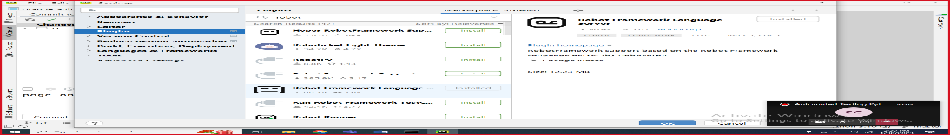Robocorp plugin
2. Install robotframework

pip install robotframework

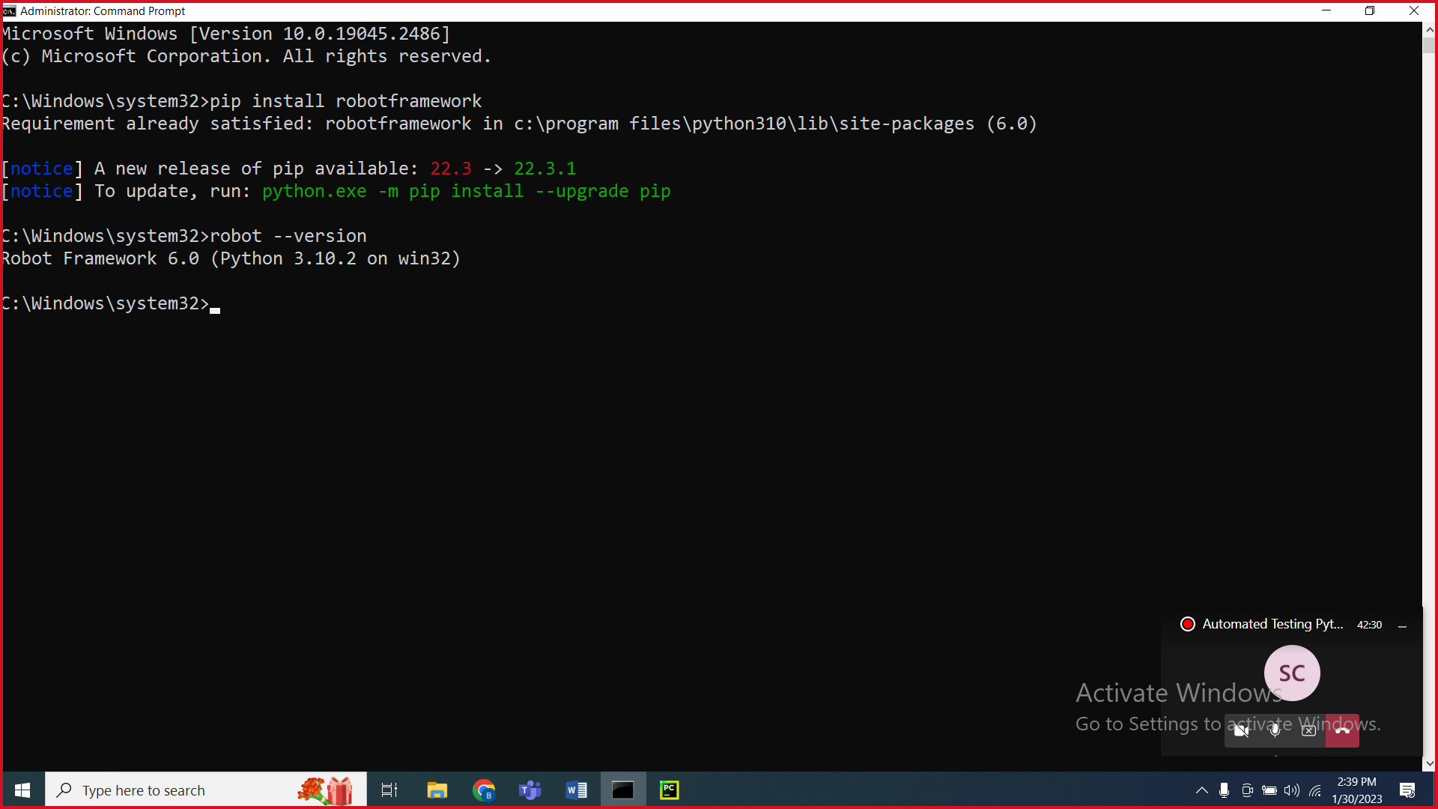

Steps to create project for robot framework

1. Create robot project
2. Create suite folder and then create suite file (.robot)
3. Sections in robot framework
   1. Settings
   2. Test Cases
   3. Variable
      1. Scalar variable ($)
      2. List (@)
      3. Dictionary (&)
   4. Keywords

Selenium Library

1. Selenium library

pip install --upgrade robotframework-seleniumlibrary

1. Selenium Keyword doc

<https://robotframework.org/SeleniumLibrary/SeleniumLibrary.html>

1. Click, type, Select
2. To inspect – tagname, attributes, text or not
3. Locating Stratergies
   1. Basic locators – id, name, classname, tagname, link, partial link
   2. Advance locators – xpath, css

When duplicate locators are there then findelement/get webelement picks the first element

1. To inspect – ctrl+shift+c
2. For page load – wait for page load to complete
3. Get WebElement/FindElement 🡪 it checks for presence of element in 0.5s
4. Synchronization
   1. Unconditional wait

Sleep 5s 🡪 not recommended

* 1. Conditional wait
     1. Implicit wait
        1. Default implicit wait – 0s
        2. Applicable for Get WebElement and Get WebElements
        3. Example: Implicit wait – 30s
           1. If element not present – it will check for 30s and then throw exception
           2. If element present – it will do the operation immediately
           3. Polling time – 0.5s (how frequently it checks)
     2. Explicit wait
        1. Exact condition
        2. Polling time – 0.5s

1. Dropdown
   1. With select tag
      1. Select From List By Label
      2. Select From List By Value
      3. Select From List By Index – starts at 0
   2. Without select tag
      1. Click Element to solve it
2. Multiple tabs/windows, alert, frame
3. Mutliple tabs/windows
   1. Switch Window title
   2. Use NEW & MAIN
4. Close Browser vs Close window
   1. Close window – close the current tab/session3
   2. Close Browser – close the browser and also kills the driver associated to it.

Faker Lib

1. Install

pip install robotframework-faker

1. Alert – javascript alert
   1. Handle Alert
2. Frame
3. Actions – mouse/keyboards

Reference

|  |  |  |
| --- | --- | --- |
| **Strategy** | **Match based on** | **Example** |
| id | Element id. | id:example |
| name | name attribute. | name:example |
| identifier | Either id or name. | identifier:example |
| class | Element class. | class:example |
| tag | Tag name. | tag:div |
| xpath | XPath expression. | xpath://div[@id="example"] |
| css | CSS selector. | css:div#example |
| dom | DOM expression. | dom:document.images[5] |
| link | Exact text a link has. | link:The example |
| partial link | Partial link text. | partial link:he ex |
| sizzle | Sizzle selector deprecated. | sizzle:div.example |
| data | Element data-* attribute | data:id:my_id |
| jquery | jQuery expression. | jquery:div.example |
| default | Keyword specific default behavior. | default:example |

Assignments

# Task 1

1. Navigate onto <https://www.salesforce.com/in/form/signup/freetrial-sales/>
2. Enter first name as “John”
3. Enter last name as “wick”
4. Enter work email as “john@gmail.com”
5. Select Job title as “IT Manager”
6. Select Employees as “101-500 employees”
7. Select country as “United Kingdom”
8. Do not fill the phone number
9. Click on check box
10. Click on start my free trial
11. Get the error message displayed “Enter a valid phone number”

# Task 2

1. Navigate onto https://www.online.citibank.co.in/
2. Close if any pop up comes
3. Click on Login
4. Click on Forgot User ID?
5. Choose Credit Card
6. Enter credit card number as 4545 5656 8887 9998
7. Enter cvv number
8. Enter date as “14/04/2022”
9. Click on Proceed
10. Get the text and print it “Please accept Terms and Conditions”